Firewall Insulation Order

Name:
Shipping Address:

Contact Phone and Email:
_____________________________________________________________________________________
Select insulation and foil thickness. (6/21/2022)
0.060" insulation, 0.002" foil Least weight , effective protection
___RV-6, 7, 9 $360
___RV-8 $290
___RV-10 $360
___RV-14 $380
0.060" insulation, 0.005" foil Smoother installed appearance
___RV-6, 7, 9 $380
___RV-8 $310
___RV-10 $380
___RV-14 $400
0.100" insulation, 0.002" foil Most effective insulation package
___RV-6, 7, 9 $400
___RV-8 $330
___RV-10 $400
___RV-14 $420
0.100" Insulation, 0.005" foil Maximum insulation and appearance
___RV-6, 7, 9 $420
___RV-8 $350
___RV-10 $420
___RV-14 $440

___RV-6, 7, 9 Cowl Exit Belly Panel Kit, 0.060" Insulation, 0.xxx" Stainless Sheet $ TBD
___RV-8 Stainless Steel Exit Ramp, 0.019", Pre-formed $ TBD
___RV-10 Cowl Exit Belly Panel Kit, 0.060" Insulation, 0.xxx" Stainless Sheet $ TBD
___RV-14 Dual Exhaust Cowl Exit Belly Panels $ TBD
Welded Tubular Firewall Penetration Fittings (free shipping when added to your insulation kit).
Singles, all sizes $ 19.00 each, unpainted.
2" x 2" 0.520" ID ____ 2"x 2" 0.650" ID____ 2"x 2" 0.900" ID____ 1.75" x 1.25" 0.520 ID____
Double tube 1.75" x 2.125" 0.520 ID____($29) Triple tube 1.75" x 3" 0.520 ID____($39)

Total your order, then mail this form and your check to:

Dan Horton, 162 Dogwood Ridge Dr, Wetumpka AL 36093.

Firewall kits include pre-marked intumescent insulation and stainless steel foil, large head SS rivets, standard SS rivets and formed SS and/or aluminum trim (where applicable), 3M Firebarrier 2000 sealant, aluminum tape, and detailed installation instructions.

Firewall kit prices include standard shipping within the contiguous 48-state USA. Other shipping may add a surcharge. Please call, text, or email for quote.

Ideas, comments, questions, and special applications (i.e. other aircraft models) are welcome. Call or text Dan at 334-315-7160, or email danhorton@elmore.rr.com

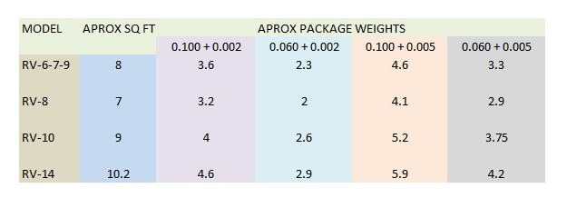
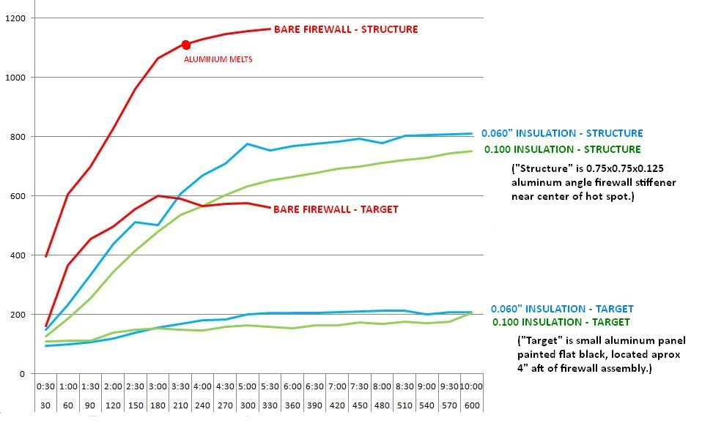

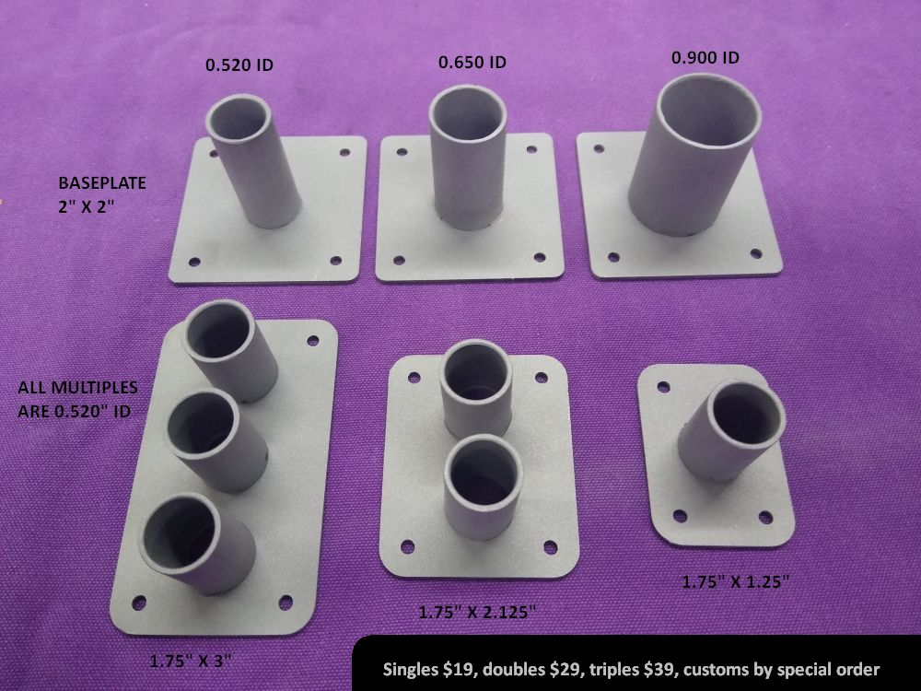
The operating principle can be described as placing a reflector over an insulator. It does not result in a fireproof airplane. The goal is to extend the available time for a descent , or to extinguish the fire, or both.
A high percentage of the heat energy is reflected by the foil. Energy not reflected passes through the stainless foil by conduction, where it is re-radiated to the insulator. Insulation slows the transfer of energy, reducing the amount of energy conducted to the airframe firewall in a given period of time.
The foil also acts as a gas and liquid barrier. In the event of an engine compartment fire, the foil blocks convective transfer, heat energy carried along by air and fluid movement, notably the hot gas blast associated with flame. 0.002" foil is surprisingly durable. 0.005" foil looks a little better, but offers no additional fire protection.
During normal operation the insulation is passive, contributing to cabin comfort. When temperatures exceed 600F, the insulation becomes intumescent, swelling to approximately three times its original thickness to further slow heat transfer. The foil will assume a "pillowed" appearance as the insulation swells. Protection will extend to approximately 2300F.
The aluminum tape has a specific purpose. The insulation fibers are held together with an organic binder. When subjected to high temperatures, the binder will outgas, and that gas is flammable. The 3M adhesive used during assembly will also emit flammable components. Sealing the gaps between firewall tabs at the perimeter prevents the entry of these gasses into the passenger compartment. The aluminum tape covering the foil overlap in the center of the firewall will melt at 1100F, providing a controlled escape path into the engine compartment.
Insulating the engine side of the firewall does not mean a builder can safely place flammable materials against the cabin side. Given an engine compartment fire as described by FAA standard (2000F over a 5" x 5" area), the cabin side may still reach temperatures capable of igniting some materials placed in contact with the hot surface, including paint. Even if not ignited, most materials can produce toxic smoke. The best choice is clean, bare stainless on the cabin side.
The author does not guarantee any specific performance or result. Purchaser accepts all risk. For installation on experimental aircraft only. Interested in a certified installation? Call us, 334-315-7160.

