Fire recovery, N3455
Abby and Matt Maisano's RV-7A caught fire on the run up pad at Pigeon Forge TN, just prior to a night departure. The fire department is located on the field, and reportedly responded in about 4 minutes, dousing the fire with straight water..no corrosive fire extinguishers.
These photos were taken a few days later, when I flew up from Alabama up for an assessment.
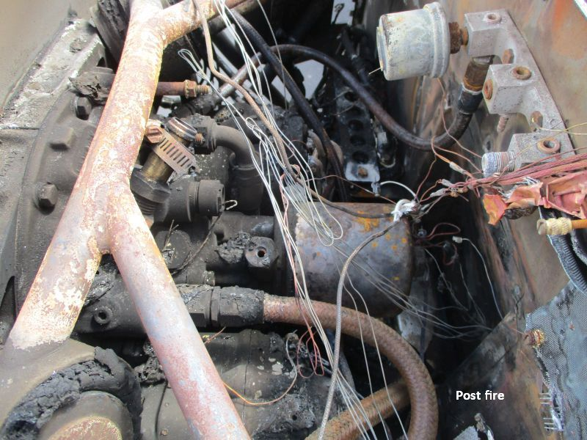
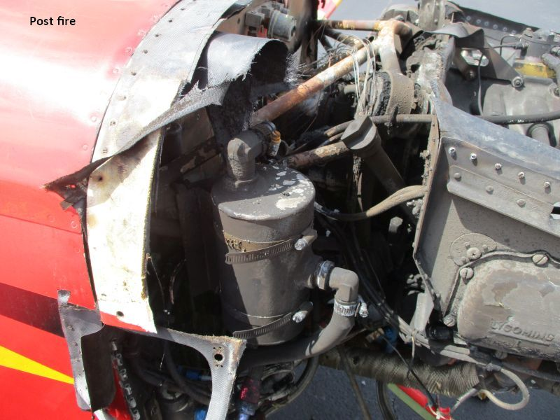
The aft area of the engine compartment was an obvious mess. However, as fires go, this one was relatively benign, as the aircraft was sitting static, engine not running, no pumps on, and no airflow. The engine case was entirely intact, as were aluminum firewall accessories like hose fittings and the inverted oil tank. Most damage was confined to plastics and rubber. Airframe heat damage appeared to be confined to the firewall assembly and the forward edge of the upper boot cowl skin. The key airframe issue of interest was no evidence of significant heating in the area of the longeron ends.
The cause of the fire was easy to identify. Look at the hose routing below, hard against two motor mount tubes and almost in contact with an exhaust pipe, a perfect storm of bad installation. A short section of rubber liner in the hose assembly baked until it was brick hard. Every time the engine was started, the hose was beaten against the mount tubes.
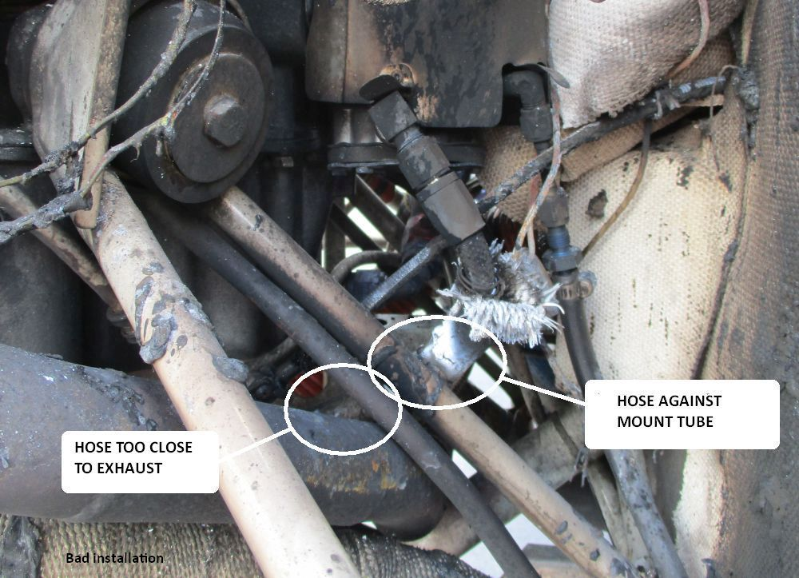
When the hose jacket was opened, the result was clear. The hardened liner cracked, releasing fuel into the fire sleeve braid, which acted like a wick. The white ends tell us the flame source was the ends of the sleeve. There was no way to tell how long it had been leaking.
The poor hose routing should have been caught in even the most cursory pre-purchase inspection. Further, recall a standard check at annual condition inspection is to remove any questionable hose and bend it while listening for the telltale snap-crackle-pop. This incident was preventable.
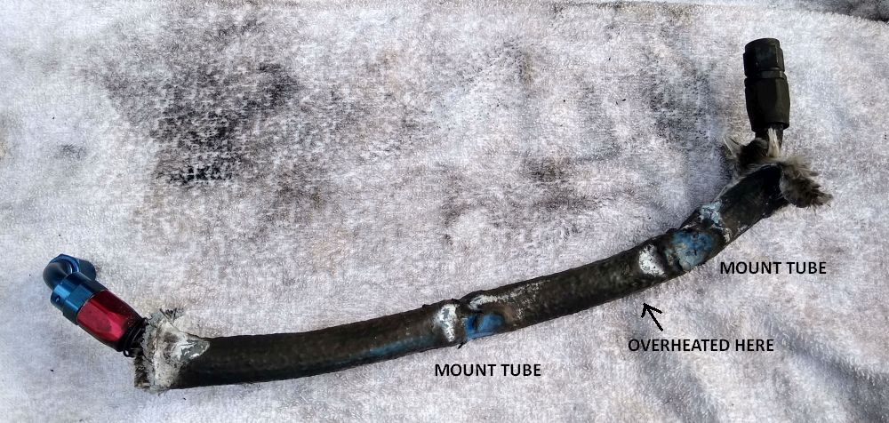
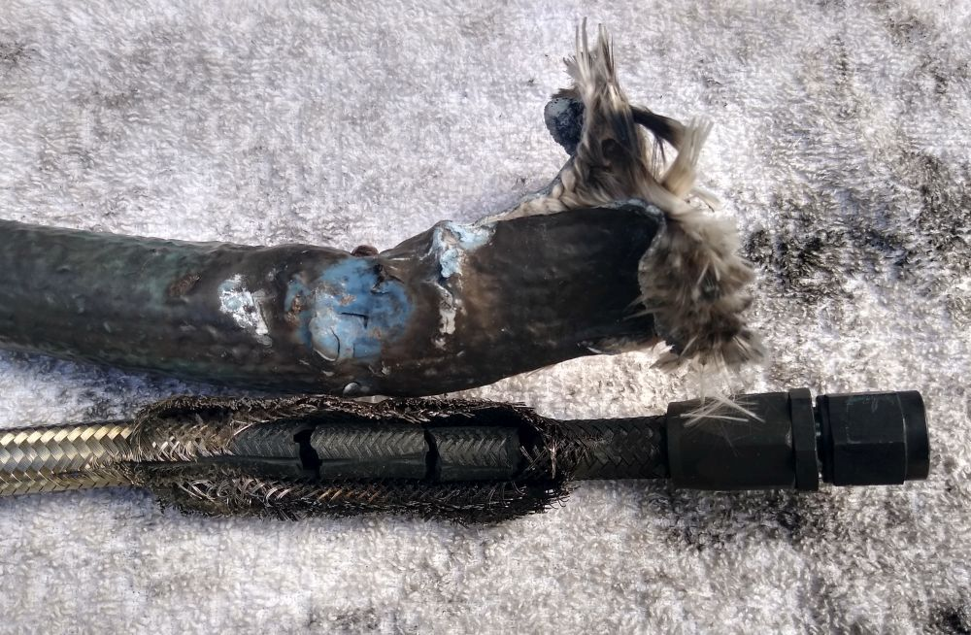
I took the logbooks home for review, and called Matt Maisano a few days later.
The aircraft had been built in Texas. It was sold and shipped to the Philippines, where it was operated by persons unknown, with annual signoffs by a Philippine A&P. It was later shipped back to the US, appearing in Florida with a new owner and new N-number. That owner suffered a collapsed nose gear and prop strike severe enough to need a motor mount change. The engine was replaced with another, which according to the logbooks, was last overhauled years ago by the Lycoming distributor in India. There was no clue as to how the engine came to the US, or where it had been during the intervening years.
My advice was to consider parting out the aircraft, because even with a lot of rebuilding, the logbook history would drag down value. The owner insisted on proceeding with a rebuild. We agreed I would recover the aircraft to my shop in Alabama for a more detailed assessment, and signed a contract for all work to be performed on an hourly fee basis, with work logs, monthly billing, and termination available to either party at any time. Best case, it would need engine cleanup, new accessory components, a new firewall, and a new cowl.
My friend Marvin McGraw lives close to KGKT, so helped me remove the wings and load for the trip south. It turned into a major task, as it was the third time the wings had been removed, and no one had ever bothered to lubricate the spar bolts. Here we are at Marvin's place, loaded, Sunday 9-11-22.
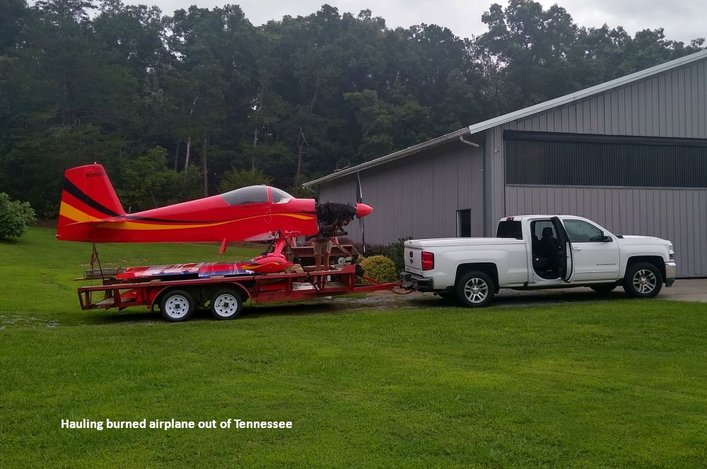

Rounded up some local friends for the unloading (thank you Ron and Stan), then the dirty work began...dismantling the burned firewall forward. The motor mount didn't seem to be damaged, although it would definitely need sandblasting and repainting.. The Precision Silver Hawk fuel injection was shipped to Airflow Performance for overhaul. Same for the 40 amp B&C alternator. All openings were capped with new fittings, or plates and gaskets, so the engine exterior could be cleaned.
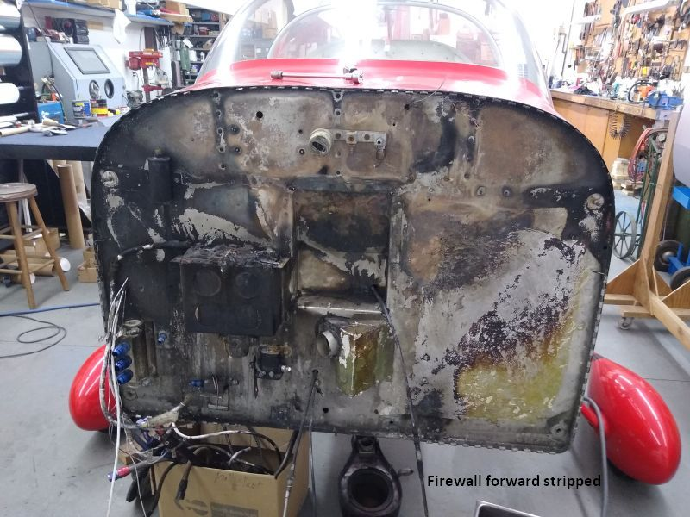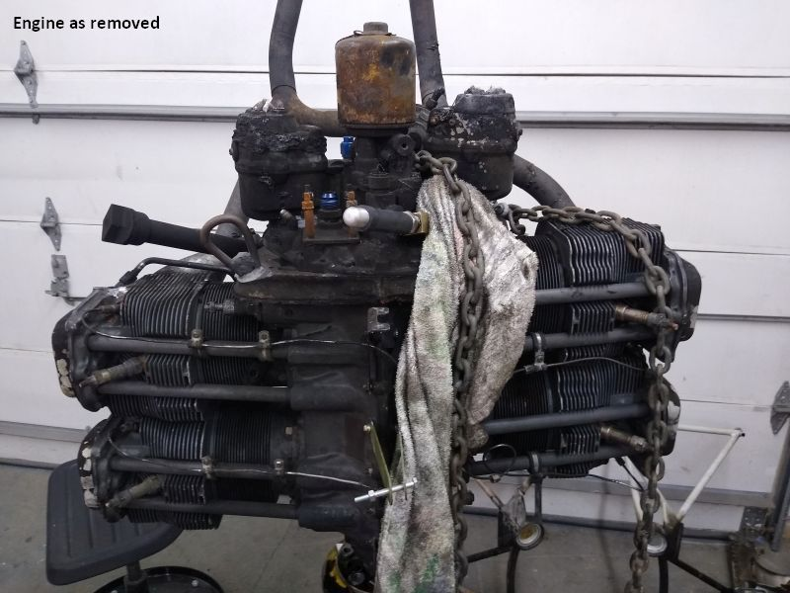
Had one of those "What the ****!!!" moments when removing the propeller. Believe it or not, someone had installed it using bolts which only engaged four threads. Here's the measurement...

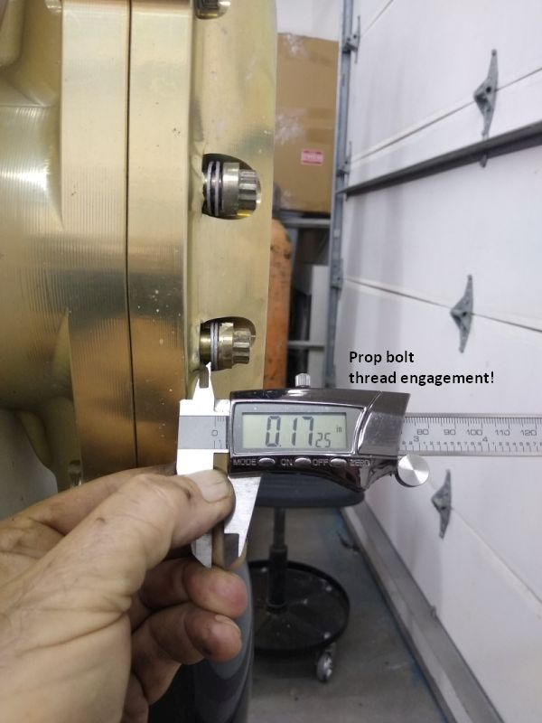
...and some of the bolts.
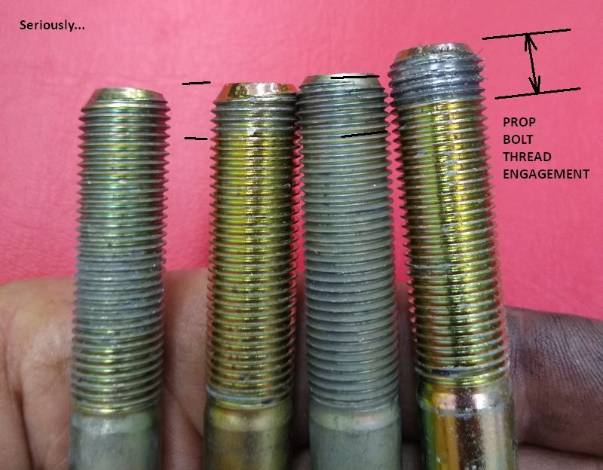
After lots of degreaser, soap, and scrubbing, the engine actually looked halfway presentable. Note undamaged case paint, a good sign.
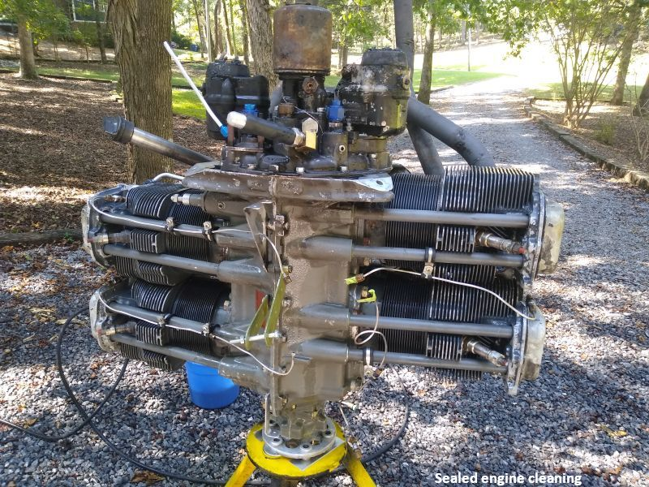
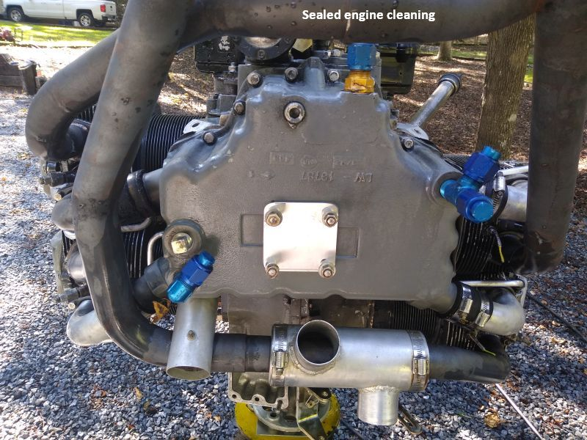
However, the good news did not last. Back in the shop, I started an internal examination, beginning with a partial tear down and a borescope inspection of the cylinders and valves.
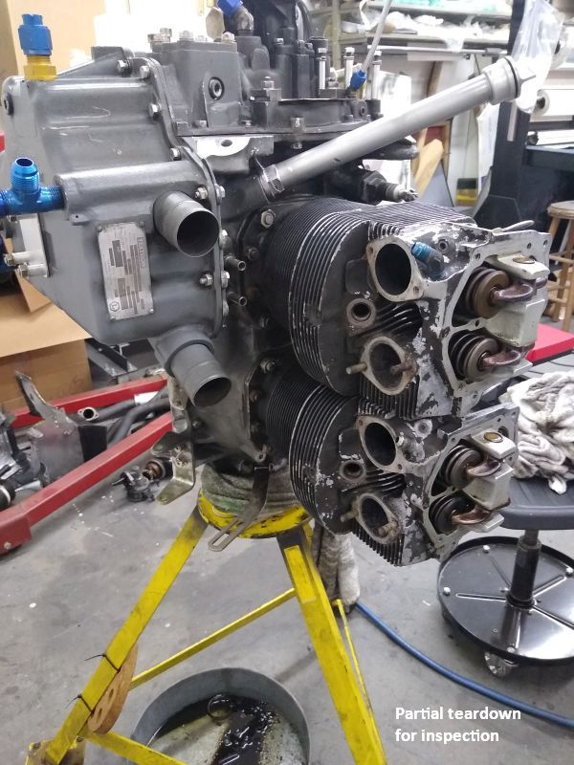
Bad signs turned up quickly. This is corrosion inside an intake pipe. It hadn't happened recently.
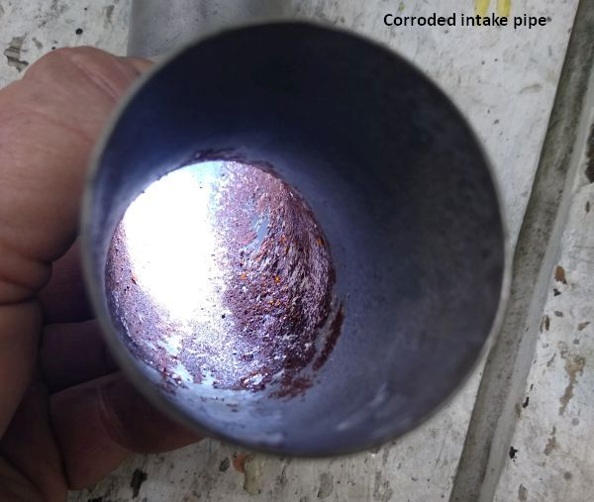
The cylinder walls were a mess, showing lots of wear and severe corrosion pitting.
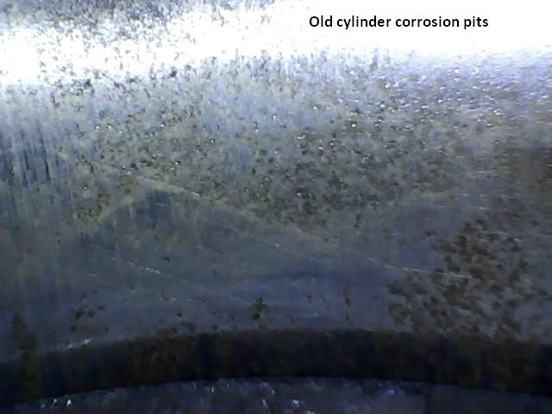
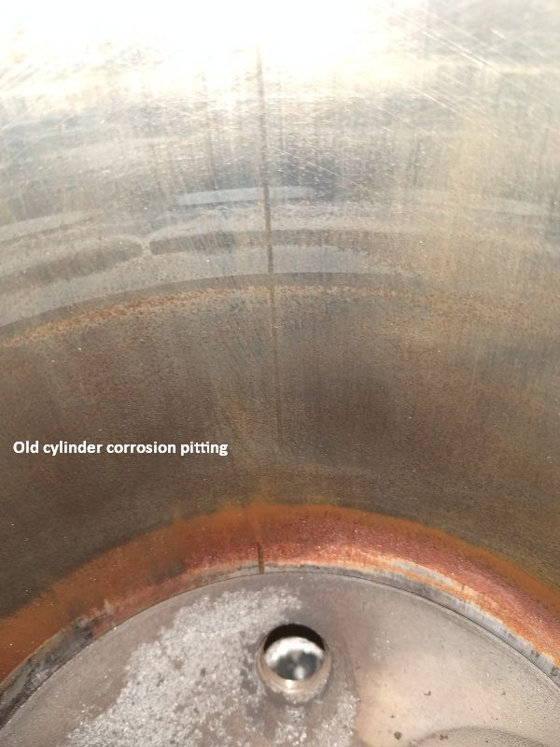
Pulled a jug for a look inside the case. Again, plenty of old rust, damaged tappets, etc. Here's a sample.
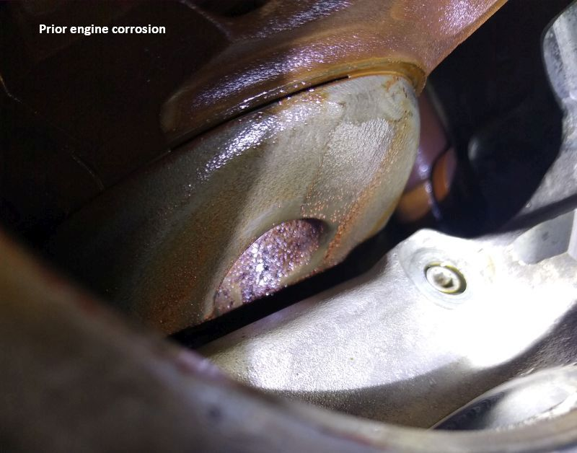
There was some liquid moisture inside the case, probably from when the fire department dumped water through the top of the cowl after the breather hose had burned away. However, there was far too much heavy corrosion to have formed in a week or two. I called Matt and gave him the bad news; this engine wasn't any good when he bought it, and for sure it needed a complete rebuild at a good shop. Eventually the decision was made to send the engine to Barrett in Tulsa. so I palletized it and put it on a truck.
Onward to the airframe. First step was to drill out the firewall panel, and get a really good look at the underlying structure.
The original builder had installed a fiber and foil insulation on the cabin side, a practice still quite common around 2010. Every plastic fiber insulation I've ever burn tested was awful, and this was no exception. The only saving grace was that being heated by a low intensity fire, the insulation didn't reach the large flame stage, but rather exhibited signs of small flame, charring, and smoking. Although it may seem like a benign result, it probably wouldn't have been survivable in flight.
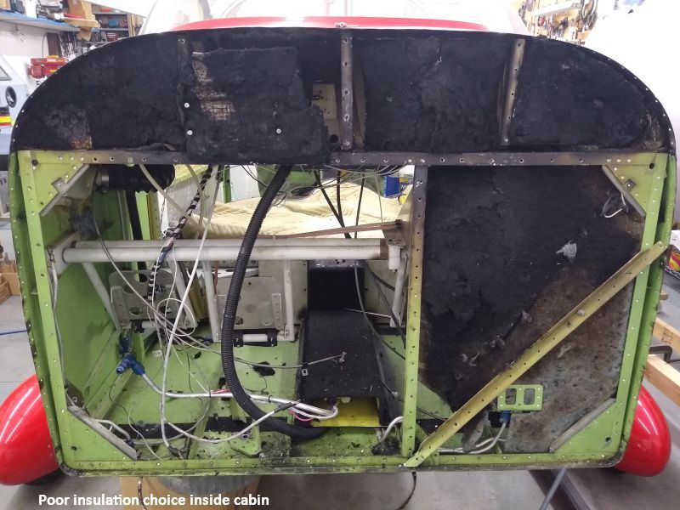
Things got hot enough to melt the plastic terminal block on the B&C regulator, inside the cabin.
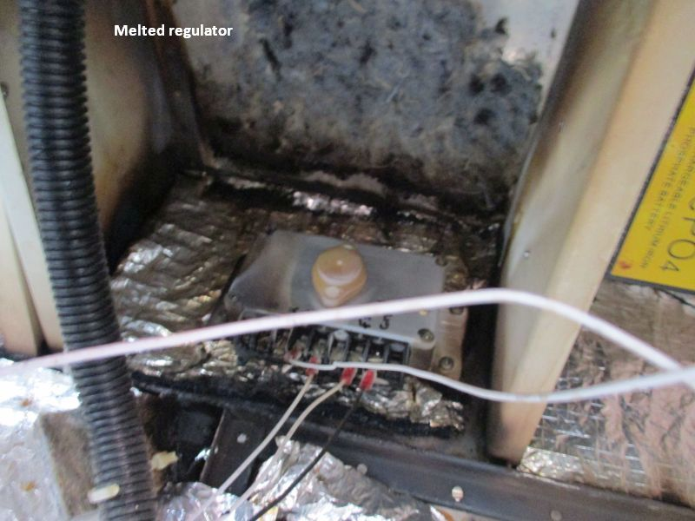
With the insulation out of the way, concern grew for how temperature may have affected the temper of the 2024-T3 skin and ribs. There were also significant corrosion issues, and evidence that the previous nose gear and motor mount replacement had not included damaged fuselage structure. The straw that broke the camel's back was the very large gouge across the windshield. After some discussion, it was decided to replace the firewall and supporting structure, the damaged skin, the 7107 and 7108 ribs, and the windshield, which as a practical matter meant pulling all the avionics and wiring.
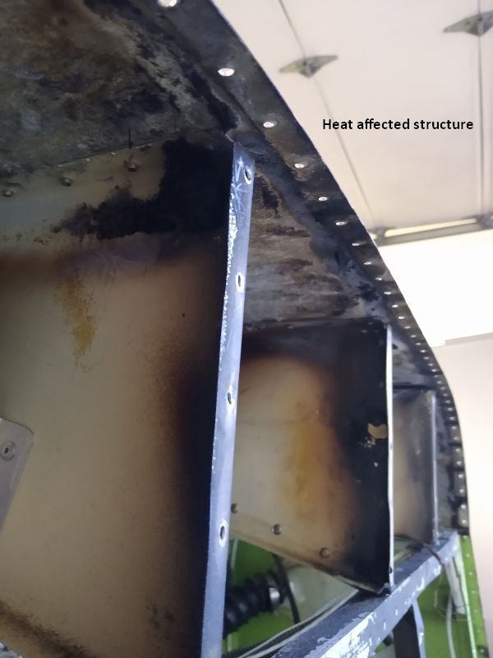
Tip: use a metal fitting on the back side of the brake fluid reservoir. The plastic fitting melts, releasing brake fluid inside the cabin...not a good thing when on fire.
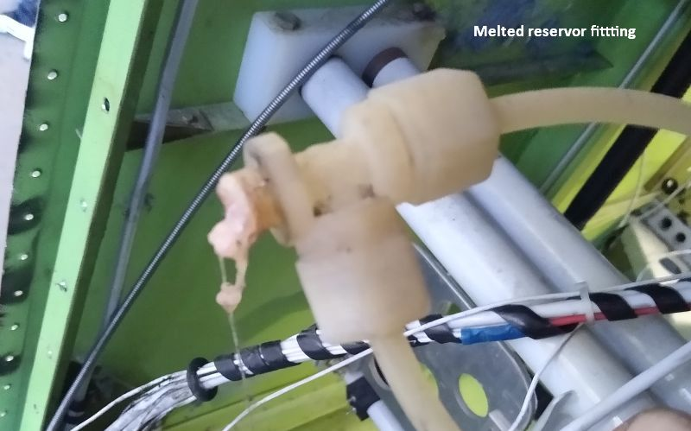

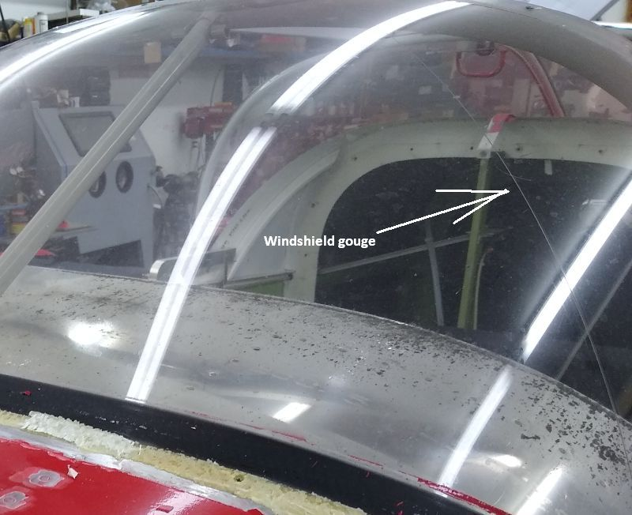
Lots of rivet removal...
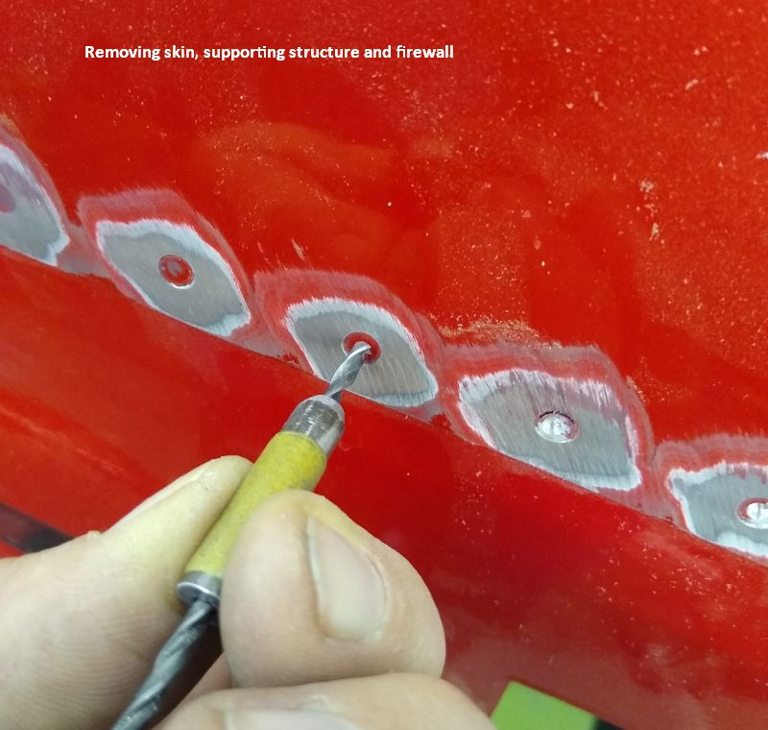
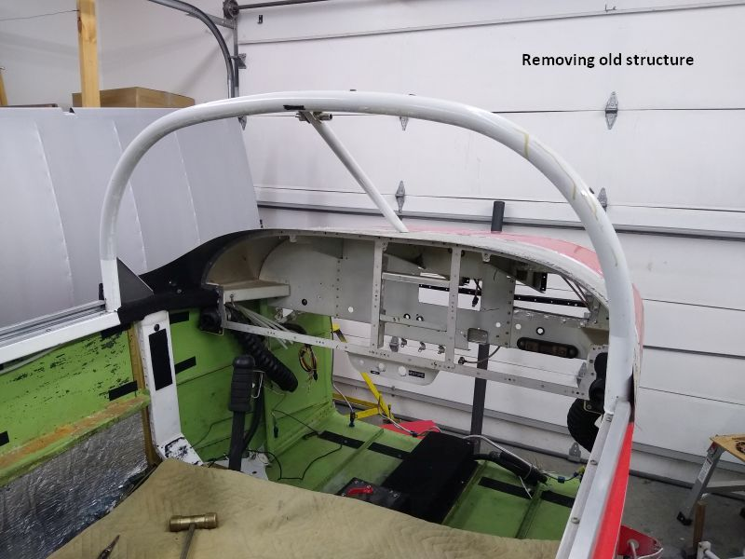

The previous incident in Florida was severe enough to shear the rivets holding the inboard lower motor mount points to the belly angles. They had not been replaced.
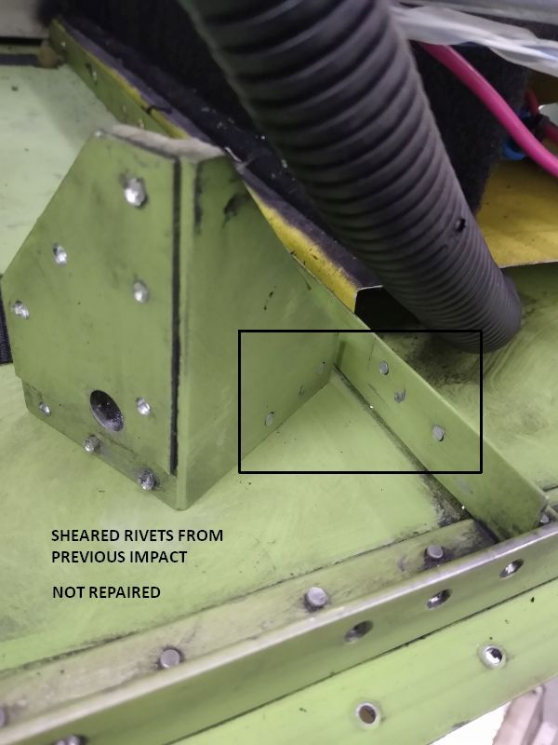

The fiber insulation held moisture, or incorporated a corrosive ingredient, or likely both, creating corrosion where it touched bolts and gussets.
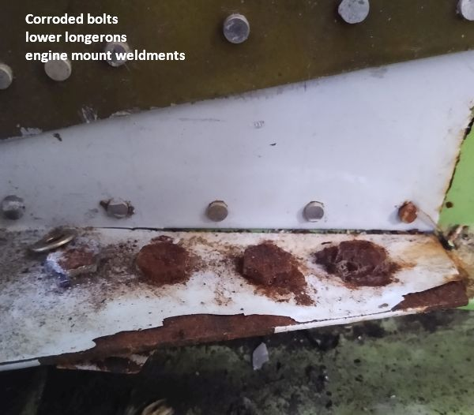
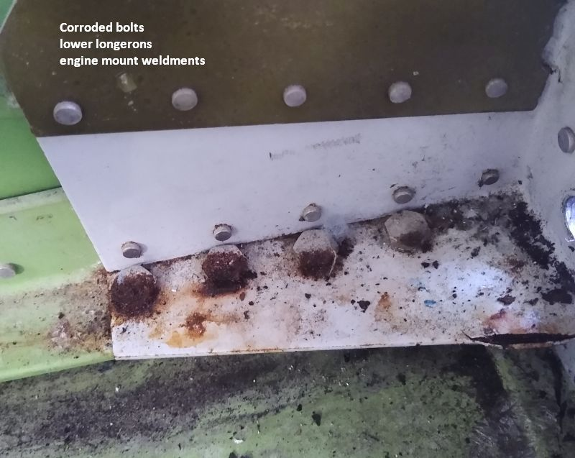
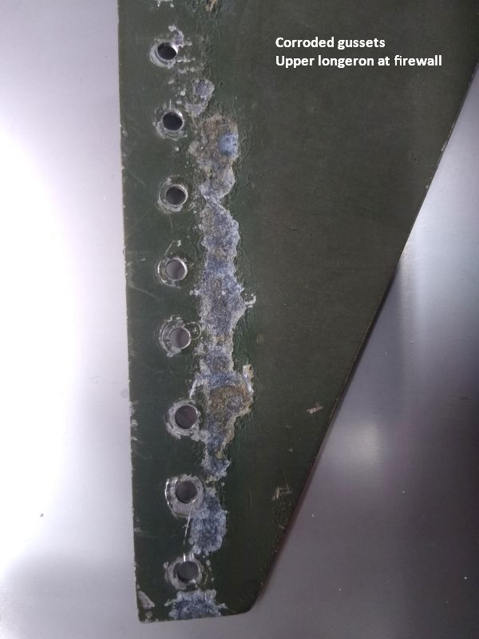

Here's an interesting detail discovered upon removal to address corrosion. One of the lower mount weldments had been countersunk on the backside of all the rivet holes. It meant the holes were knife edged at the rivet shanks... and the build error was hidden from view, impossible to find on inspection.
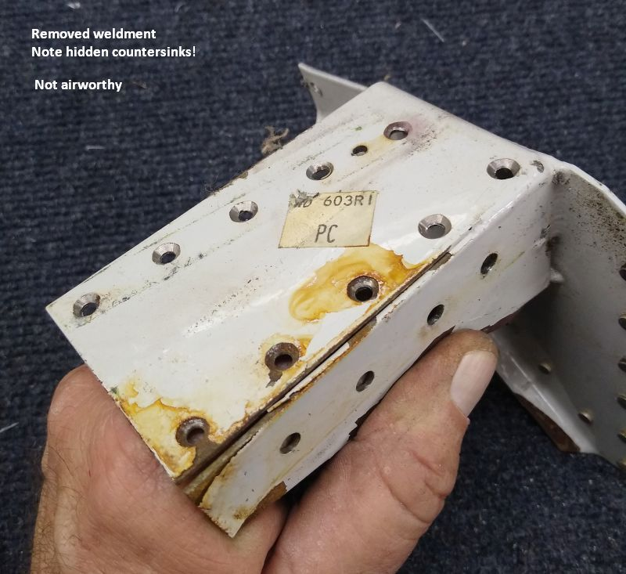

Recovery from the Florida incident had apparently included a sling or perhaps a forklift under the fuselage just forward of the wing roots. Lack of care resulted in badly crushing the F-772 bottom skin at the curve below the longerons, on both sides. I was able to make a suitable dolly and work the crushed area back to something close to the desired profile, or at least close enough for a painter to smooth with a bit of filler.
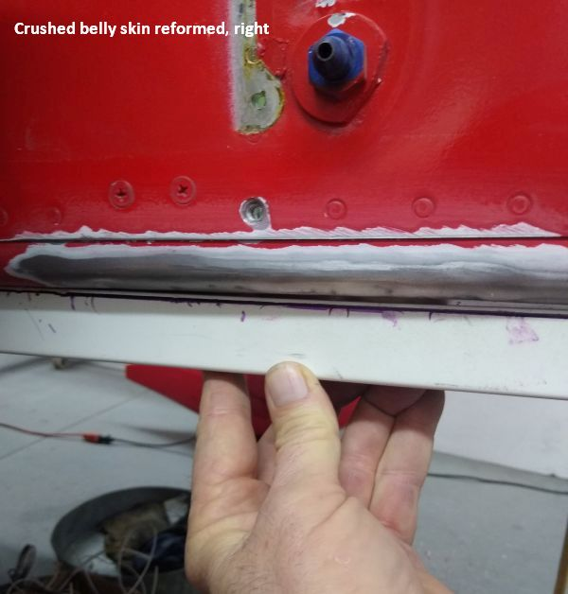
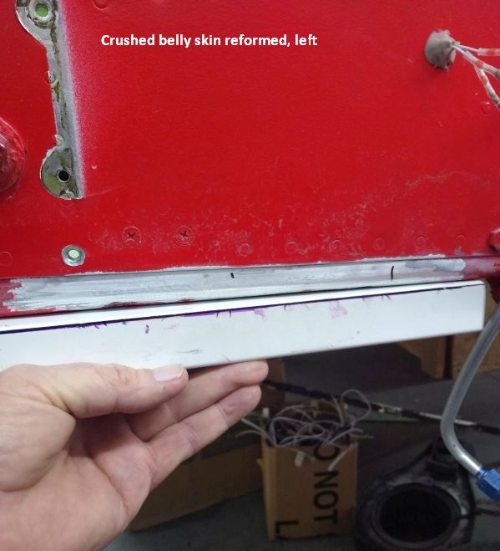
Going back with new parts required a long session with the Vans order pages, plus wait time, but it got done. First item to fabricate was a new firewall....
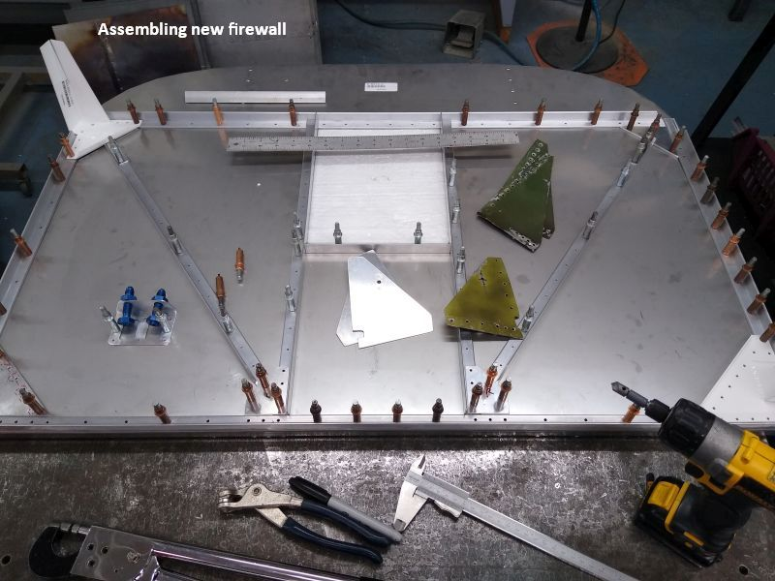
...so it could be slipped into place to determine if the forward fuselage was deformed from previous incidents. Good news; it was close enough.
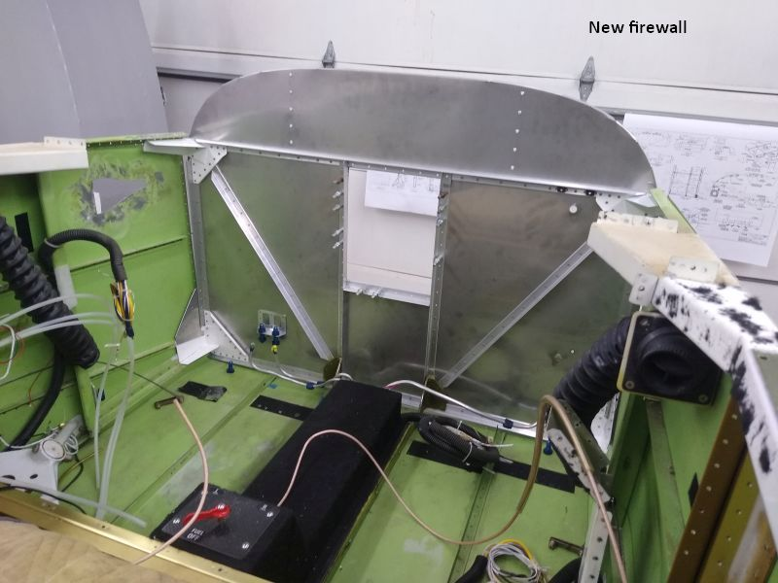
I did need to work out an edge distance correction with Vans engineering. The holes in the new lower left weldment had to be matched to the existing holes in the old longeron angle, which were too far outboard. The fix was one additional bolt at the red circle. The alternative would have required replacing a section of longeron. Probably would have been fine with four bolts, as it flew that way for 12 years, but...
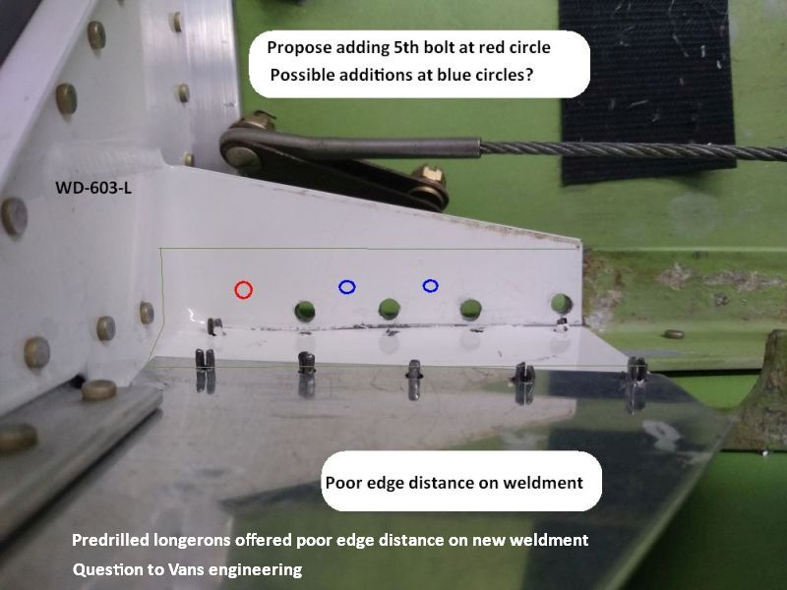

Removing the wings from a 6A, 7A, or 9A entails a lot of hard work to get the spar bolts out, and it must be done with the forward seat pan panels removed in order to access the aft side of the main spar. The upshot is a serious risk of deforming the floor ribs while working hunched down in the cockpit. Having been shipped to Southeast Asia and back, the wings had been on and off a few times, and the floor ribs aft of the main spar were a bent mess with previous substandard repairs. I removed the scabby stuff and worked the ribs until straight again, then fabricated new doublers for the weakest.
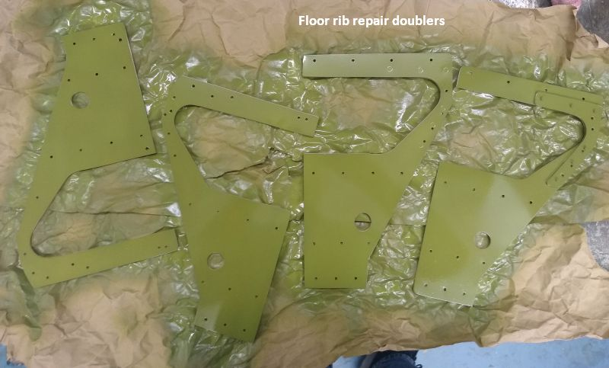
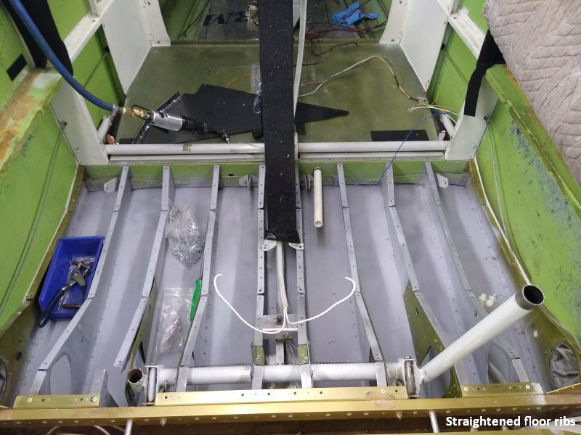
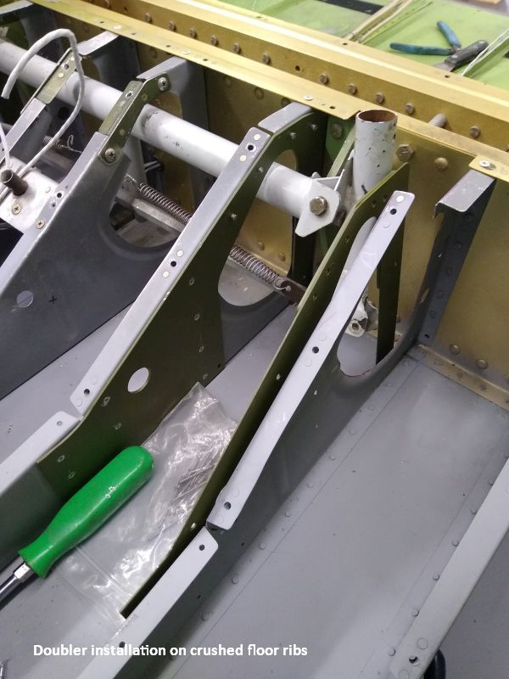
Here's a common error seen on 6-7-9 models. Folks install the sticks vertical, when they should be rigged leaning forward a bit. If rigged vertical, they tend to bind the rod end shank at the torque tube arm at full up elevator, which puts a bending load on the threaded fitting...bad juju. Check for it. This one wasn't too bad, but some really bend the threaded part of the fitting, and it should be replaced, or at least crack checked.
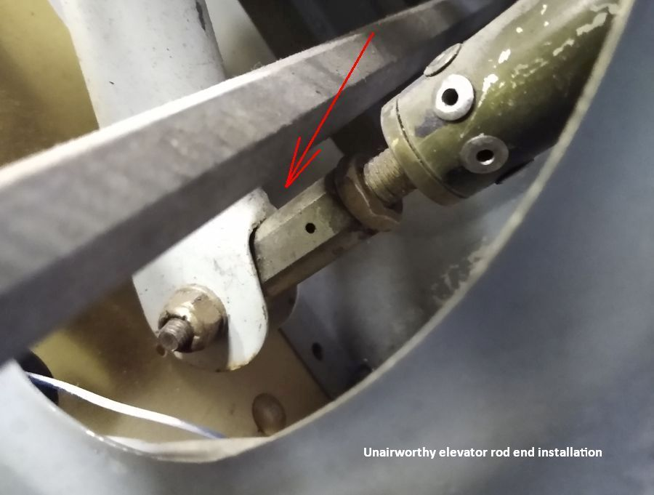
The static system was found disconnected, and complete with a water trap, not that it mattered.
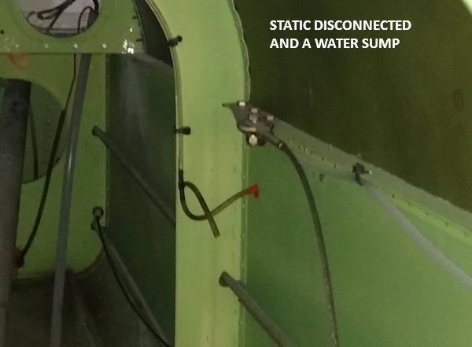
I'm not a big fan of pop rivet static ports. They work fine, but have no barbs to retain the hose. I usually machine ports, as they 're easy to make and only require a dime's worth of aluminum stock.
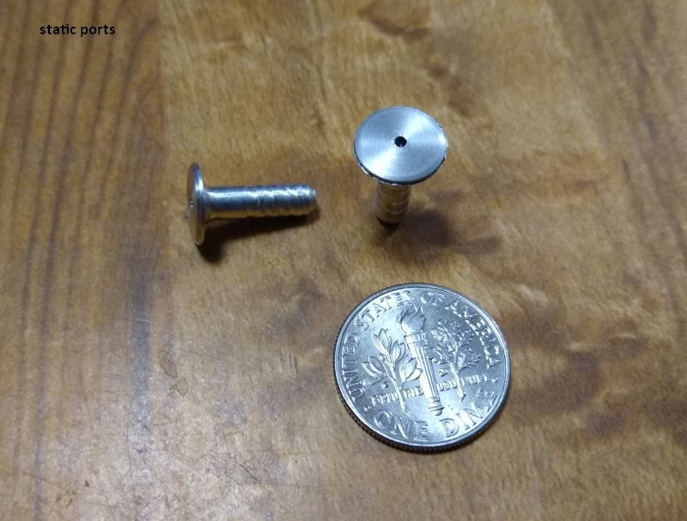
The existing zipper rudder was unairworthy, having been previously bent in a wind incident, straightened, and kluged back together at the lower trailing edge. I suggested replacement with an RV-8 rudder for better overspeed margin, so we ordered a full rudder kit and new upper caps.
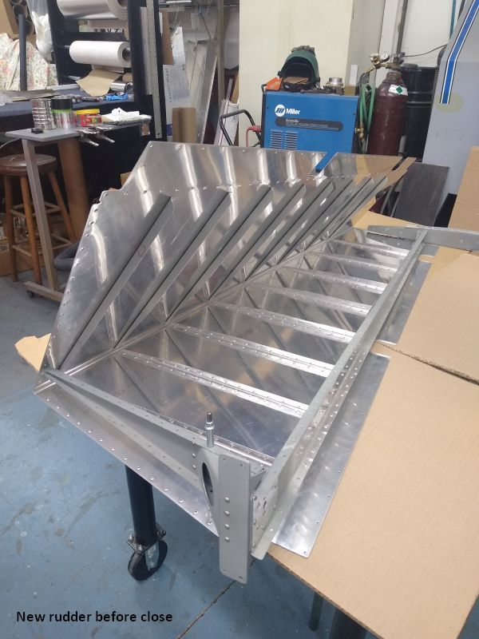
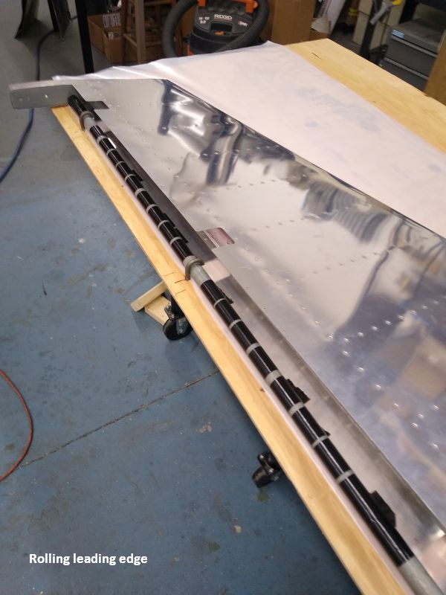

Built a perfectly lovely new rudder, complete with faired and matched caps, but it was for naught. Bad timing. As it turned out, the kit was produced smack in the middle of the laser parts series, and supposedly incorporated four major "Replacement Recommended" components...so it was drilled apart, only to find nothing wrong with the named components. Sheesh. (At this writing, parts are still not available.)

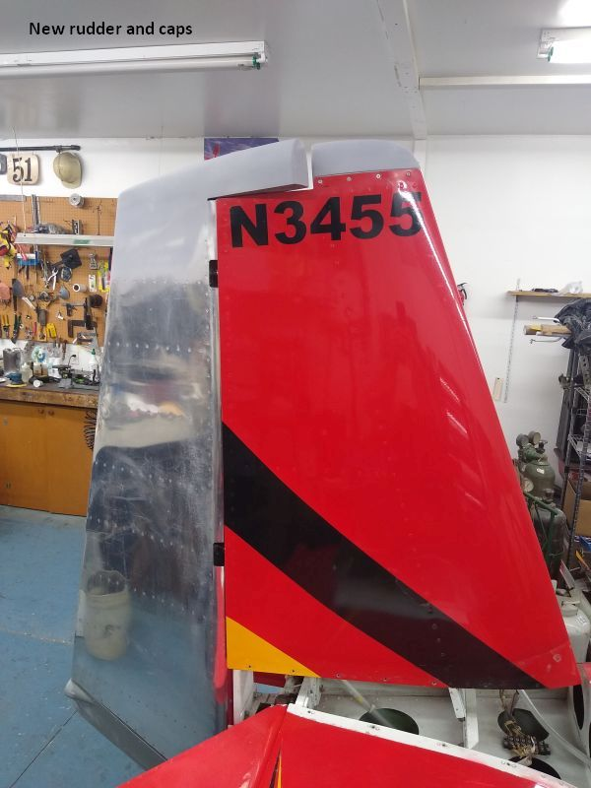

The wind incident had also torn a rudder stop off the fuselage. Someone had re-attached it with a sheet metal screw. The hole enlargement meant there wasn't any good way to rivet it properly, so I ditched the external stops and installed a nylon internal stop. Frankly, I'm not a big fan of the internal stop, but here it was a reasonable fix.
Match drilling the new firewall to the existing skins went well, as did the upper fuselage assembly.
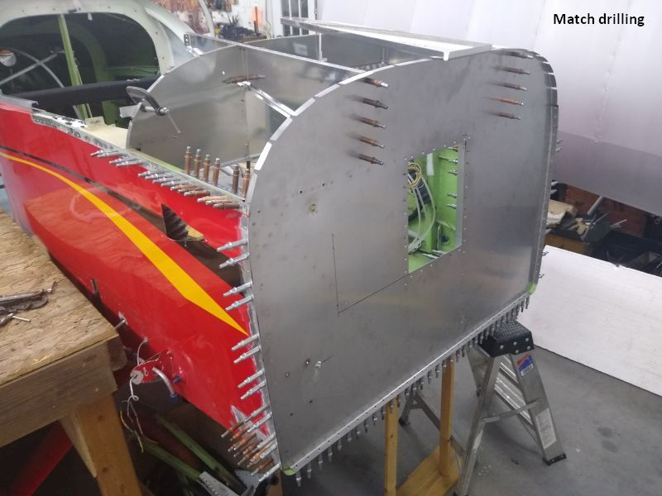
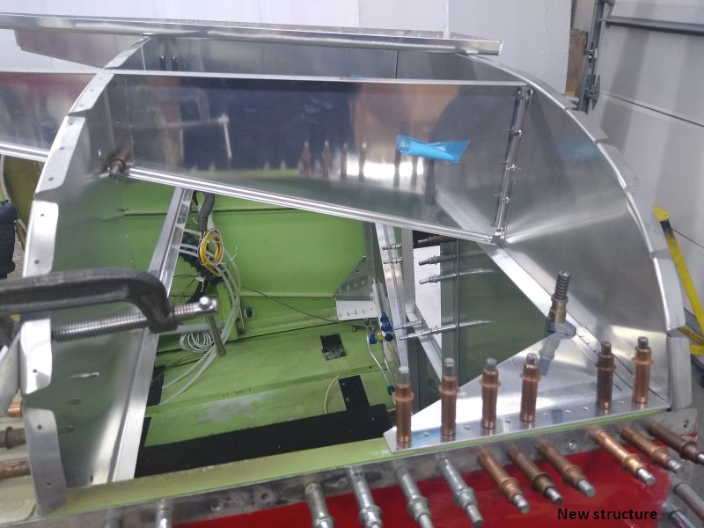

The upper skin was rolled for fit, then it was the usual routine involving a forest of clecos, match drilling deburring , dimpling, etc, until it was all ready to rivet.
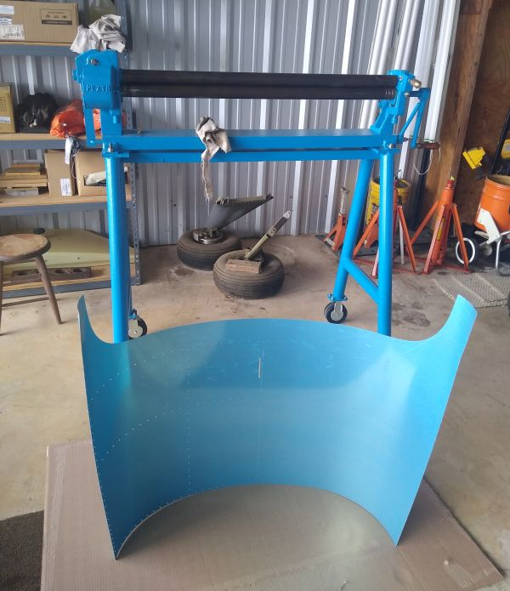
Somewhere in the process, Maisano asked if I could also install all new avionics, and eventually settled on a dual Garmin G3X system with a G5, a 375, and dual remote coms, all in an Aerosport carbon panel.
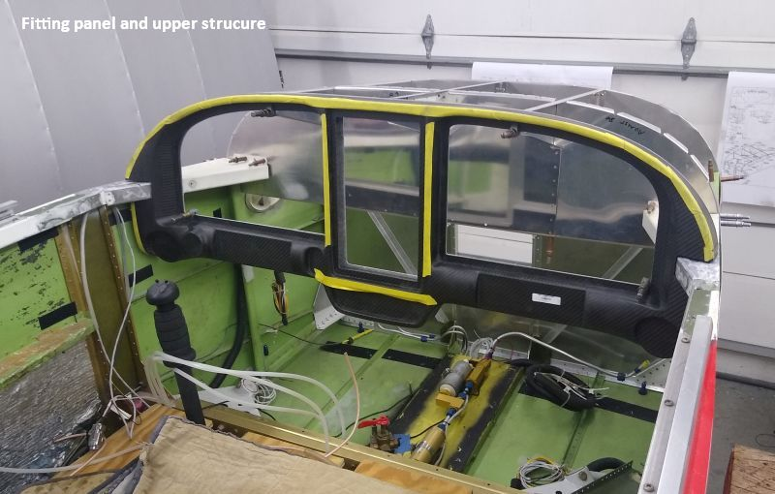
It would be quite a while until we had an engine, but it was time to plan engine choices. The original path was to keep the Silver Hawk injection and perhaps replace the burned Slicks with one or more EI's. I was recommending a new Slick and a Surefly, for simplicity and overall low cost, with an SDS CPI2 as an alternate plan. However, while looking at the CPI2, Maisano got interested in electronic fuel injection. I explained it would require both a duplex fuel system and a new electrical system. The orders were "Do it", so out came the old systems.
The Andair duplex valve requires some tube bending, but it's mostly straightforward. Had to get -6 return fittings from the UK. No US stock.
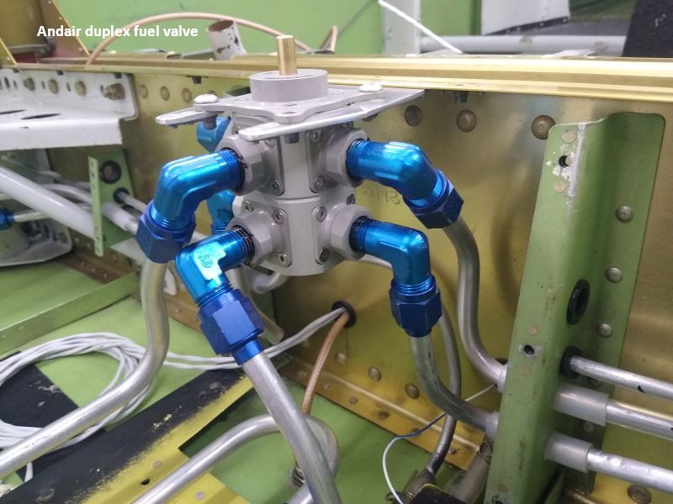
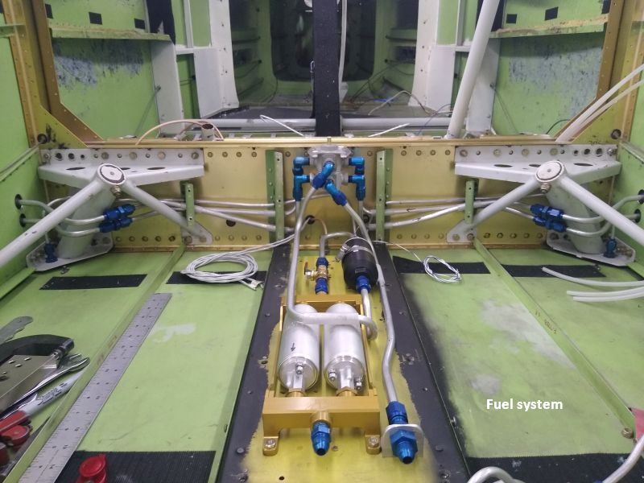
Arranging the pump package with a 1/4-turn valve allowed removal of the filter for cleaning without a major fuel spill in the cockpit. Close the valve, disconnect the lines at the finger and at the screwdriver:
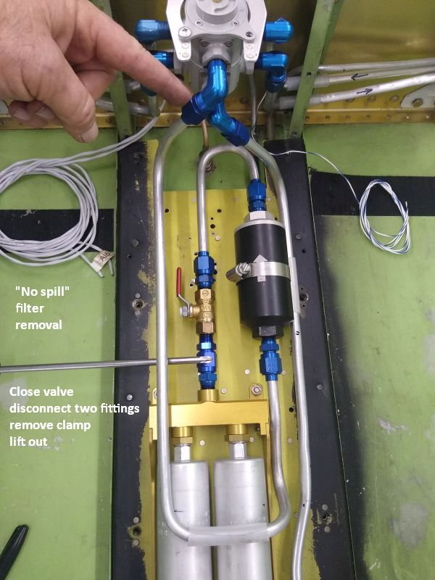

Also installed line breaks to allow moving or removing the fuel lines during installation of the spar bolts. The smaller brake lines were crushed at the fittings (the spar bolts again), so they too were replaced.
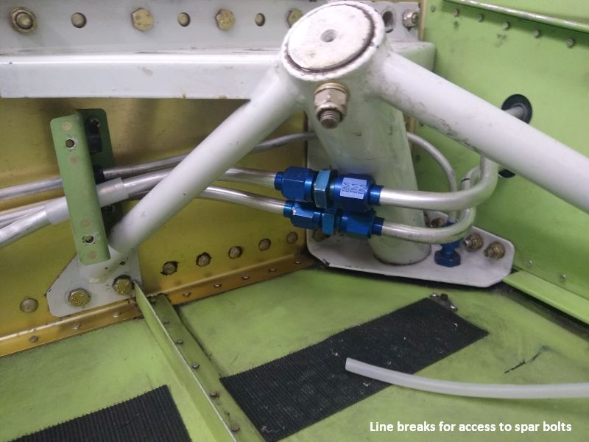
Electrical power for EFI required design, here a dual bus system. We settled on dual alternators and dual batteries, as Maisano wanted IFR capability. He also wanted heated seats, so the primary alternator needed an upgrade to 60 amp. The Monkworkz MZ-30 was selected for the backup.
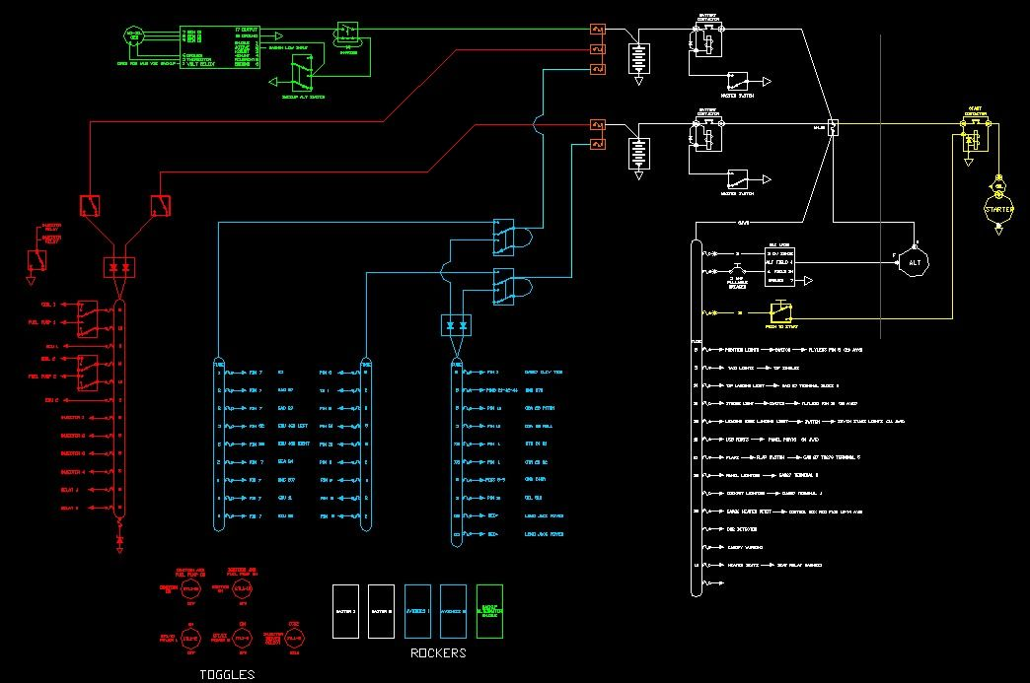
Ran a basic failure analysis, posted online for peer review, researched details with vendors, worked out wire sizing and fusing, then primary distribution routing. The key design focus was on human factors, the goal being a minimal requirement for pilot action following any single failure.
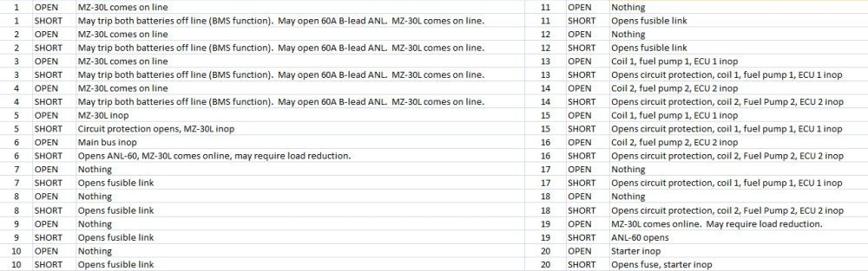
While that was going on, I was also coordinating with Green Mountain Avionics, Maisano's chosen vendor. They would send the LRUs and screens to me, but cut and engrave the panel inserts as well as fabricate an interconnect harness. Peter at Green Mountain was great to work with, but still, it was almost too many cooks in the kitchen.
Quick, everyone agree on position and labeling!
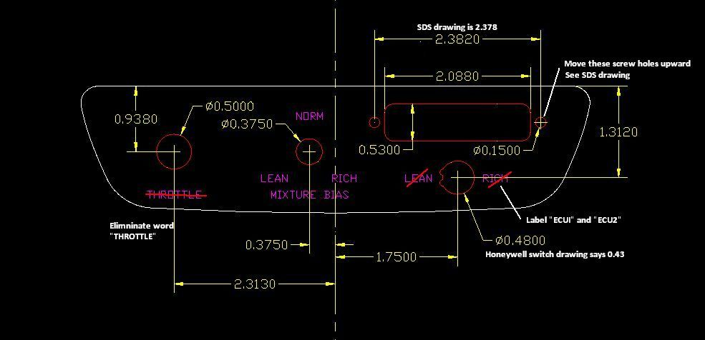

The remote com radios and audio went on a fabricated mount behind the baggage compartment, alongside a new elevator servo installation, and a new ELT.
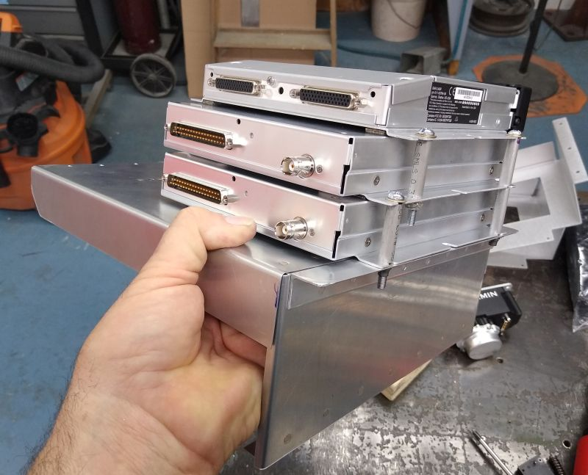
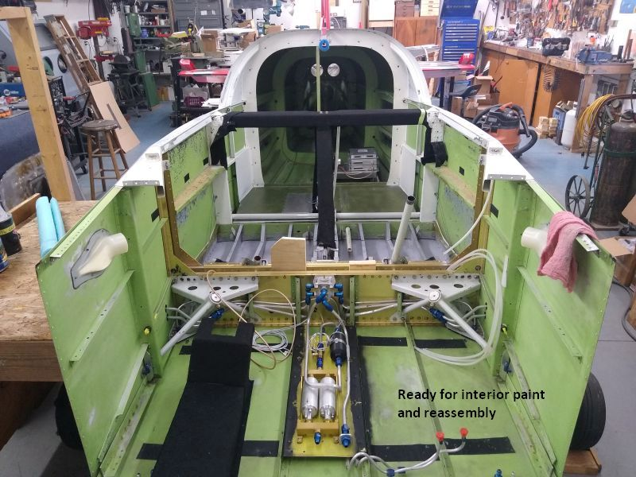
The belly got a second com antenna on a doubler, and a new belly strobe.
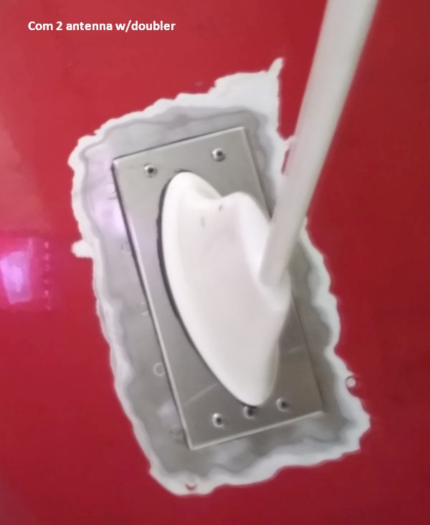
The EarthX batteries would go inside the fuselage, which required the vented case version and external battery vents. I machined simple barbed vent fittings in a suitable diameter and mounted them near the fuel vents. The external end is nearly flush.
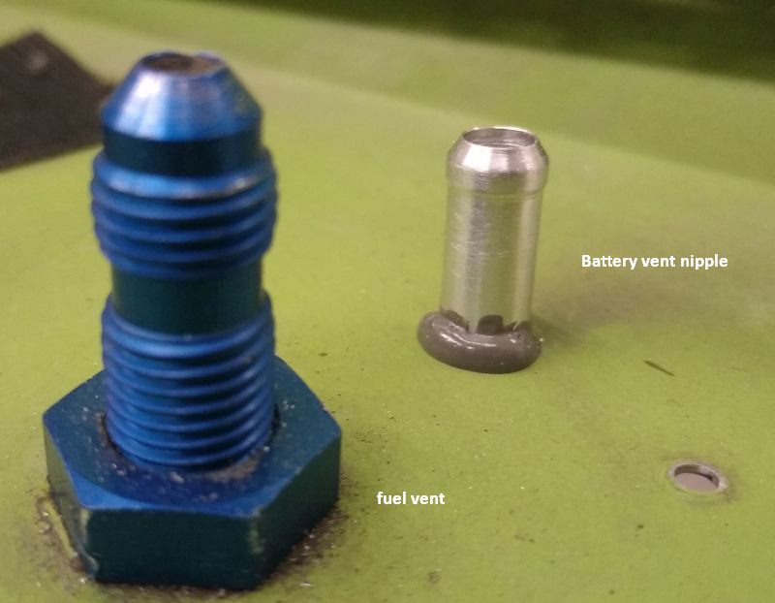
Hooray! The engine finally came back after nearly a year. Very nice...
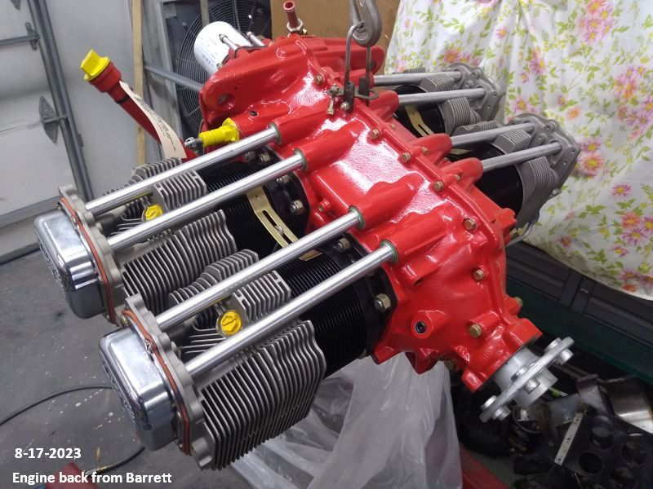
Jig and drill a new motor mount. Why new? Note the pivot points. This is the retrofit mount for the RV-10/14 style nose gear. Machined drill bushings ensure the bolt holes went in the center of the cups. The cups will accommodate bolt holes a little off center if needed to match an old firewall, but here we were drilling a fresh firewall, and could have used either style of the new mount.
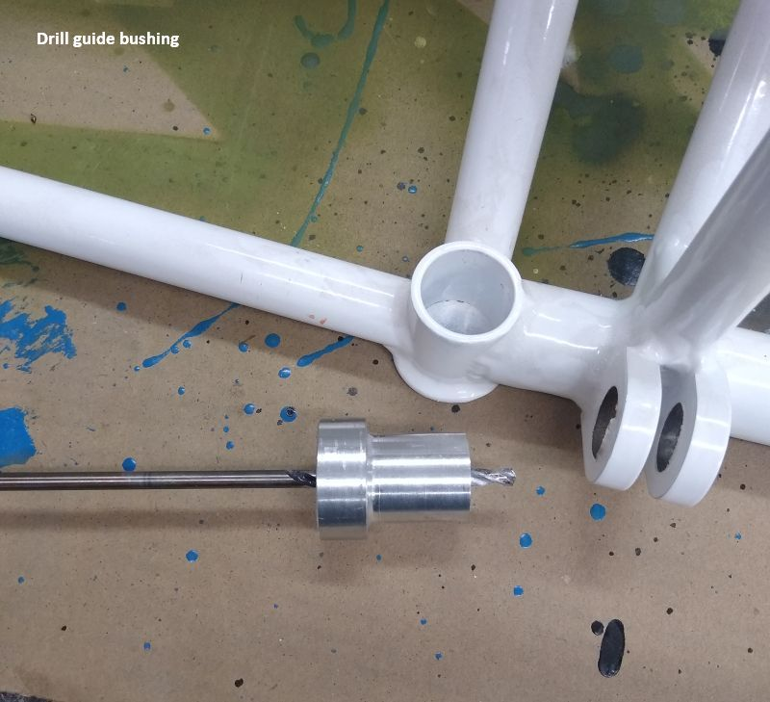
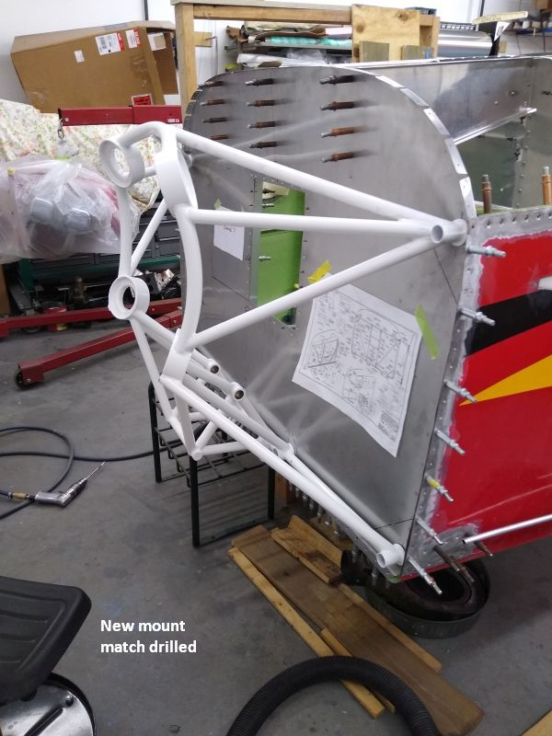
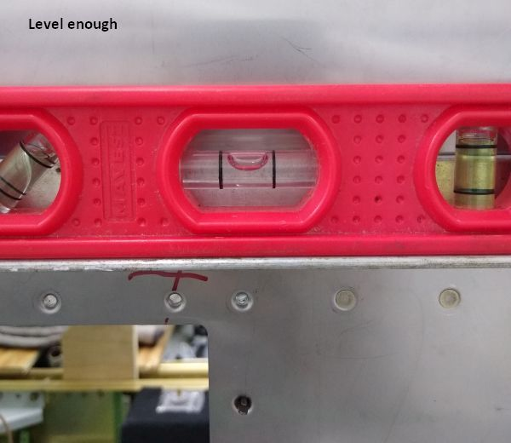

Laying out and installing mounting points for firewall accessories. No batteries in the engine compartment freed space for the remote mount cooler and inverted tank , and still leaves lots of room for maintenance. Note blown dish recess. No prop governor, so all it needed was a little room to get the horizontal oil filter on and off. Final product, not shown, was a matching dish with insulation sandwiched between.
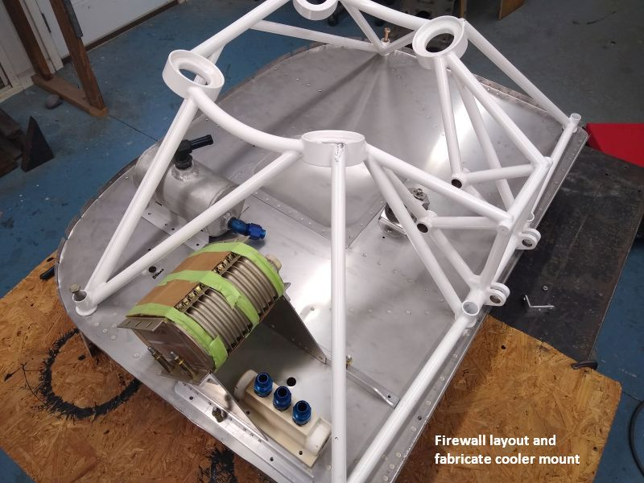
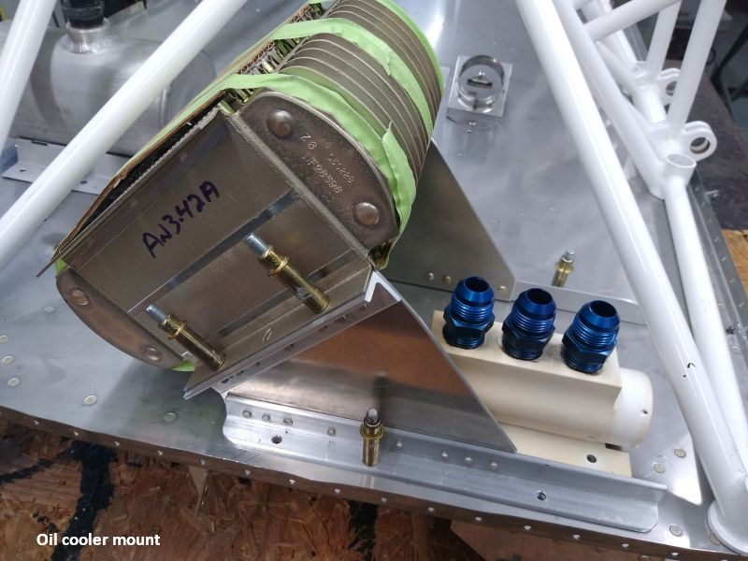
All the Garmin LRU mounts, fuse blocks, and other components are on nutplates, so they will be easy to R&R from the seats by simply removing a G3X screen. The 25C AHRS got a reinforced doubler for stability. Harness from the forward bay routes through grommet on right.
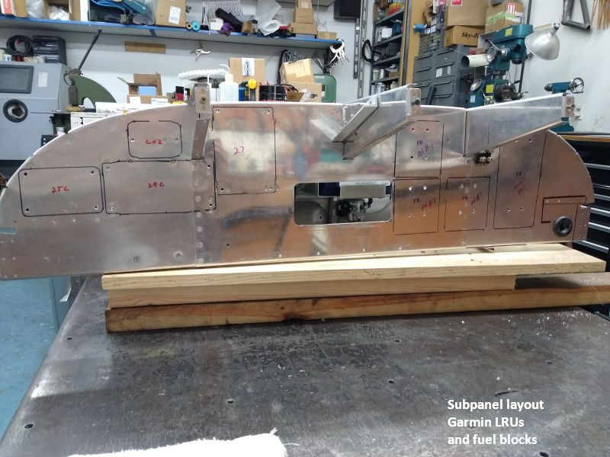
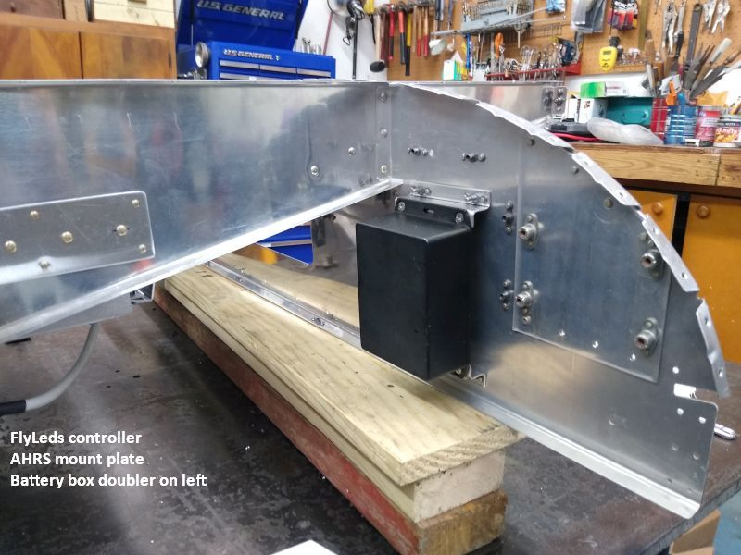
Forward bay with dual batteries, EFI/EI fuse block and diode block, dual SDS ECU, power distribution bus, and the Garmin EIS.
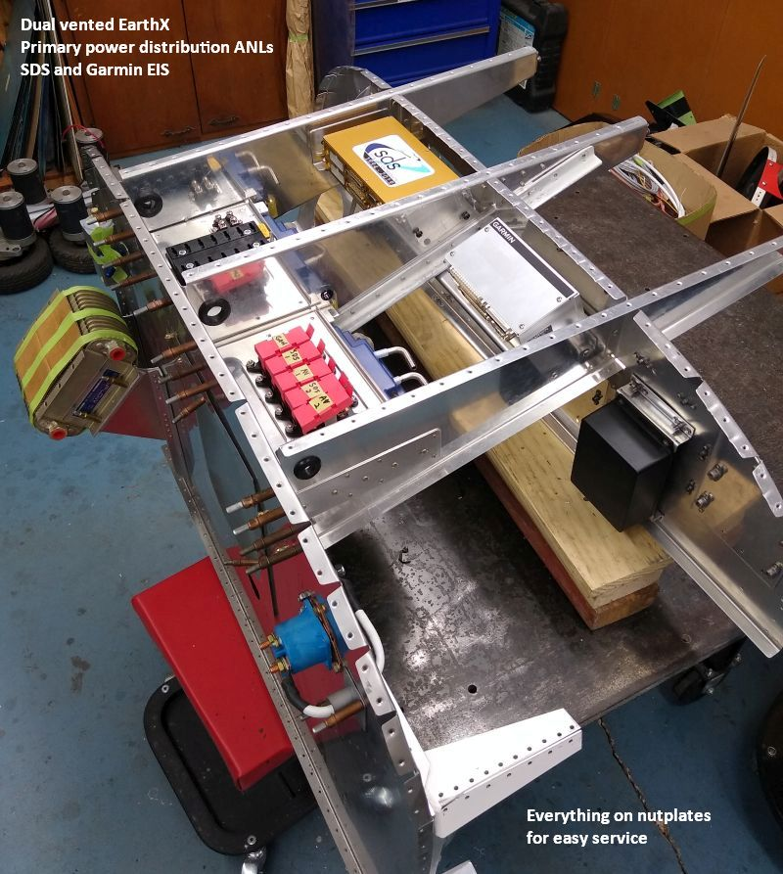
It's all easily serviced through the access panels. The goal is to minimize any requirement to go upside down under the panel. I was able to form decent "gaskets" from proseal, but they may leak anyway. Not to worry; the power blocks are on raised supports, and the electronics are tucked well aft of the hatches. For insurance, they should all have a rain shield.
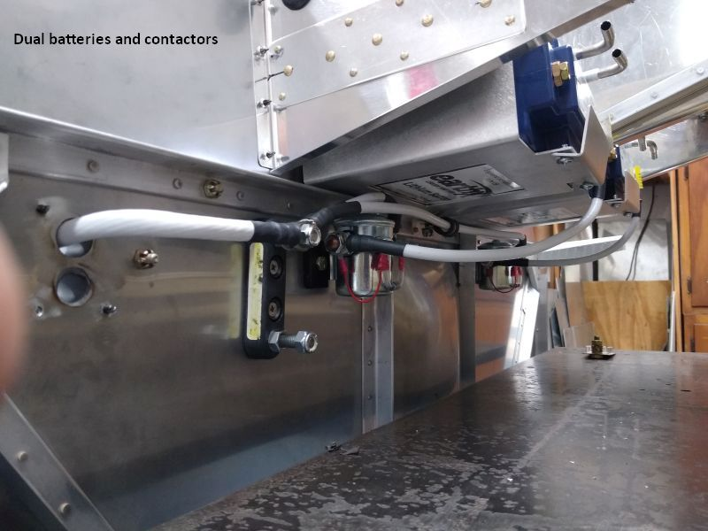
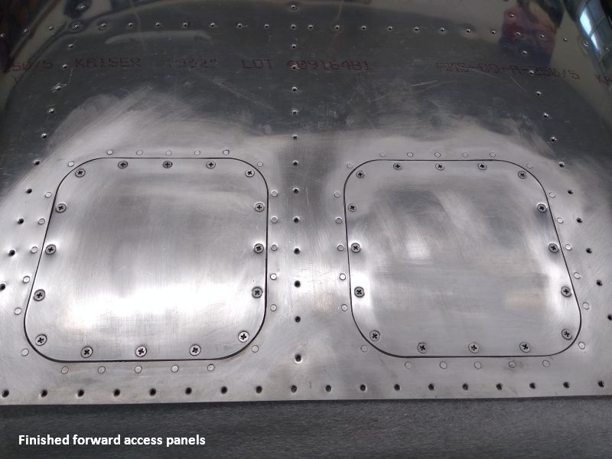
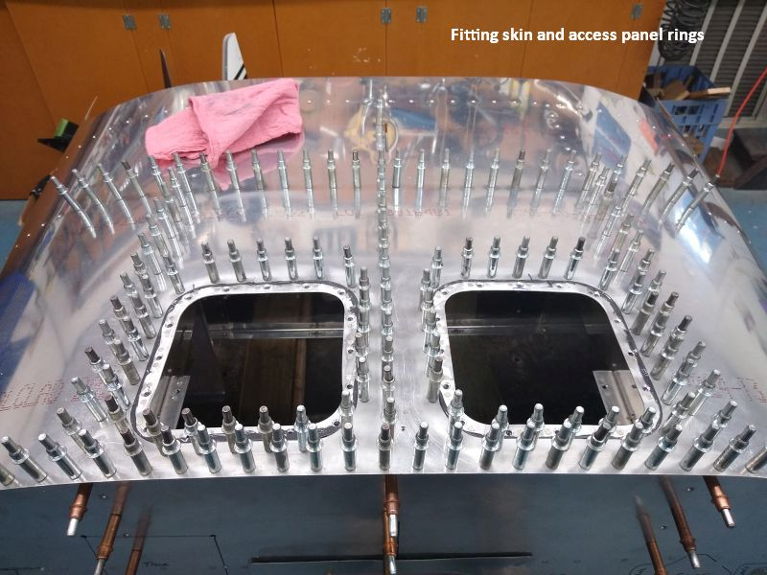
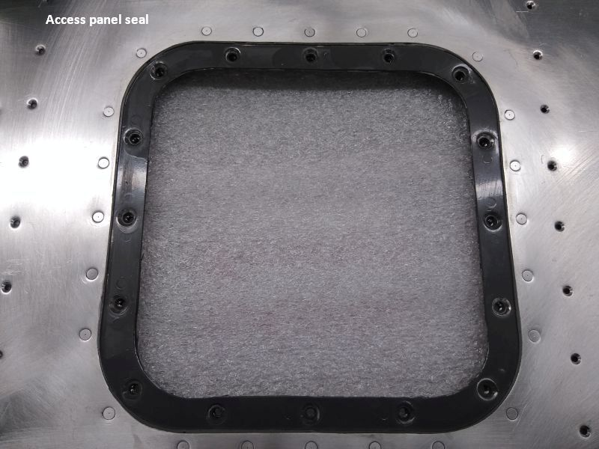
That wraps it for me. The Maisanos recently moved to an airpark home, with shop space and airplane capable neighbors. In early November they elected to finish the project at home. I hauled the wings and a load of parts to Georgia, and they picked up the rest a few days later.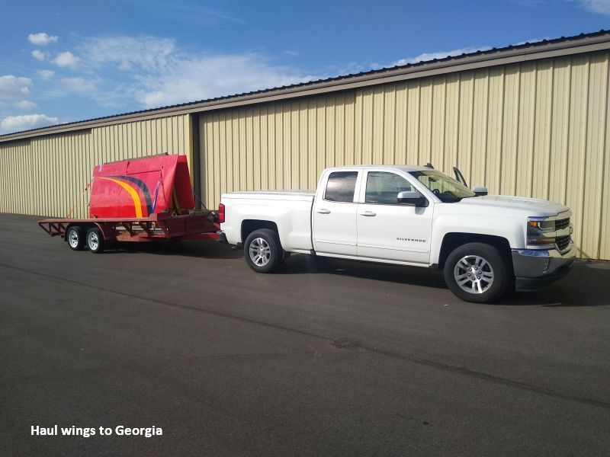
There's still much to do, but the heavy lifting is done. Wings aside, from here it's just assembly, then a strip and repaint. Given time, it may yet be a nice airplane.
Dan Horton
12/01/23

_______________________________________________________________
Postscript
Friends report a sock puppet named "Sarah Everly" has been posting smear ads on various Facebook groups. Here's an example...
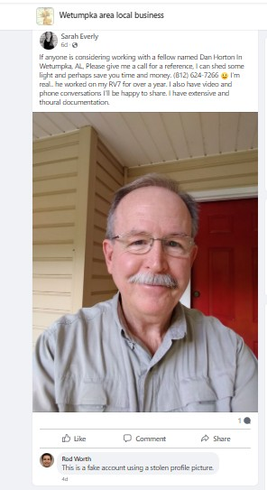
The profile photo appears to be lifted from a website, as the young lady in the picture is a dance instructor from Lafayette LA. https://basinartslafayette.com/profile/sarah-swinney/
I've never met a Sarah Everly, or Sarah Swinney. The only RV-7 work I've done recently is detailed above. I have to assume the sock puppet is actually Abby Maisano (note "my RV7"), but readers can draw their own conclusion.
So, why?
I'm confident Matt never really considered how much time and money it would take to install all the items he requested in addition to fire repair, despite long phone calls discussing each change. His response to cost was always "It doesn't matter. I'm going to keep it forever". None of those calls included Abby, the registered owner of the aircraft.
For sure, neither Maisano appeared to grasp the true condition of the airframe, or the scope of corrections required to become airworthy....even after it nearly killed them.
Labor was invoiced each month, with a work log. Much of the actual time invested (initial assesment, aircraft recovery, planning, hauling, packing, shipping, shopping, phone consultation, and more) was free, as for me, this was a showcase project, a literal phoenix from the ashes. The Maisanos were welcome to visit at any time. By contract, they could have pulled the airplane at any point if not satisfied. Yet all was good, until suddenly it wasn't.
If I were to speculate (and quote Cannery Row), I'd say the world was spinning on greased grooves until they bought a very expensive new house, and Abby started asking hard questions about Matt's spending. Guess who got blamed.

